Install micropython-servo package to your pico w

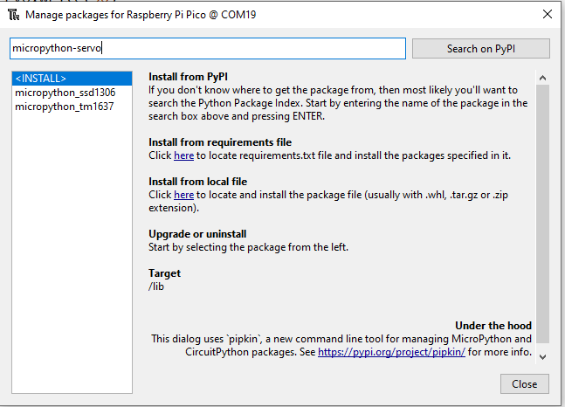

Click Search on PyPi

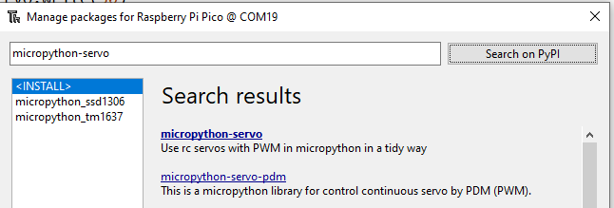

Click on **micropython-servo** link

Click Install

You should see the library inside the left-hand panel after it is successfully installed

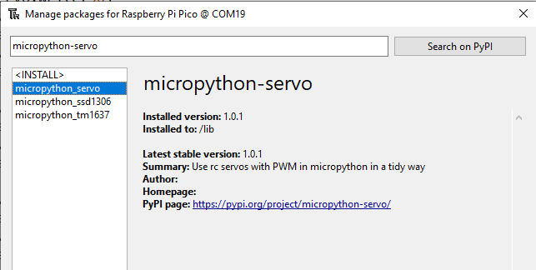

You should be able to see a folder named servo inside your lib folder

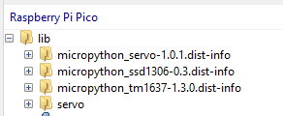

Click on the https link to find out more about this library and instructions how to use it.

PyPI page: <https://pypi.org/project/micropython-servo/>

<https://www.instructables.com/How-to-Connect-HC-SR04-Ultrasonic-With-Raspberry-P/>